Laiba Irfan
31736
Operating Systems
Lab 4: Traps

(1) answers :

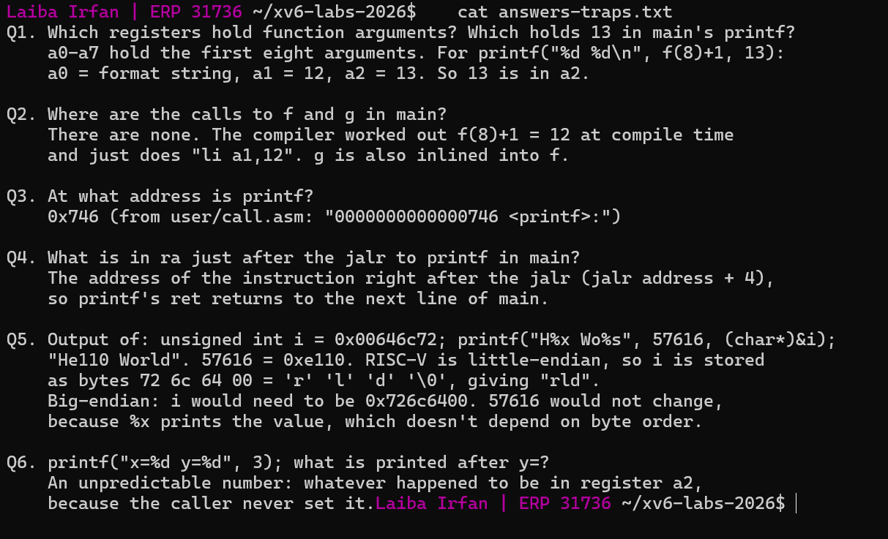
(2) backtrace :
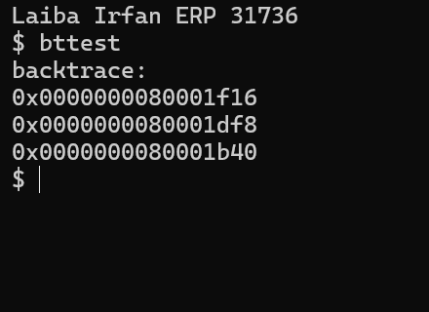

(3) addr2line :

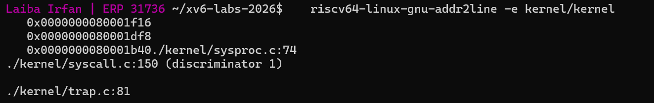

(4) alarmtest :

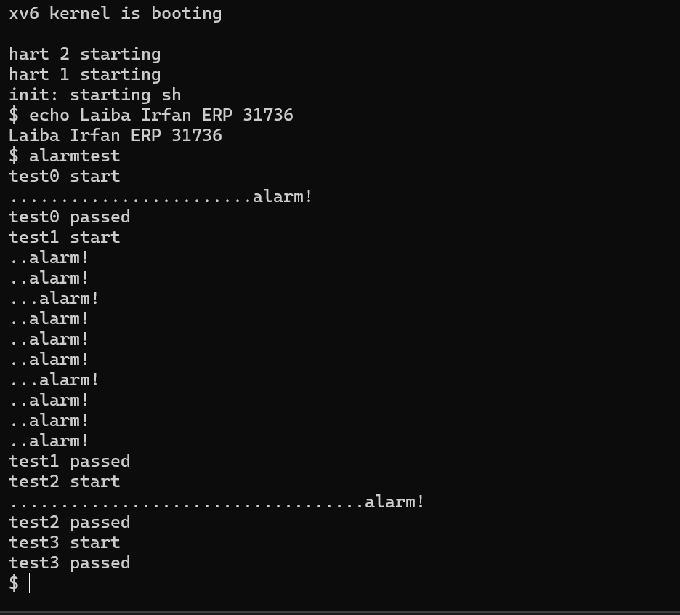

(5) make-grade :

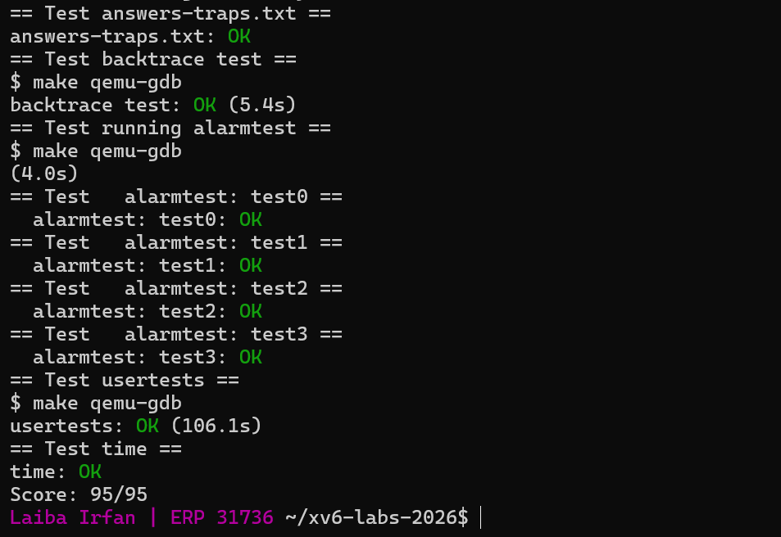

(6) Challenge :

